Chapter 7, Problem 43.

Consider the circuit in Fig. 7.110. Find i(t) for t < 0 and t > 0.

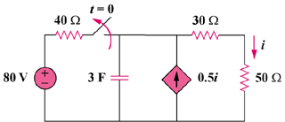

Figure 7.110
For Prob. 7.43.

